MDMA’s 40-year fight for medical approval continues
The FDA rejected MDMA-assisted therapy, lengthening an already decades-long journey to medicalize the psychedelic.
by Haleema Shah
Updated Aug 13, 2024, 3:13 PM EDT

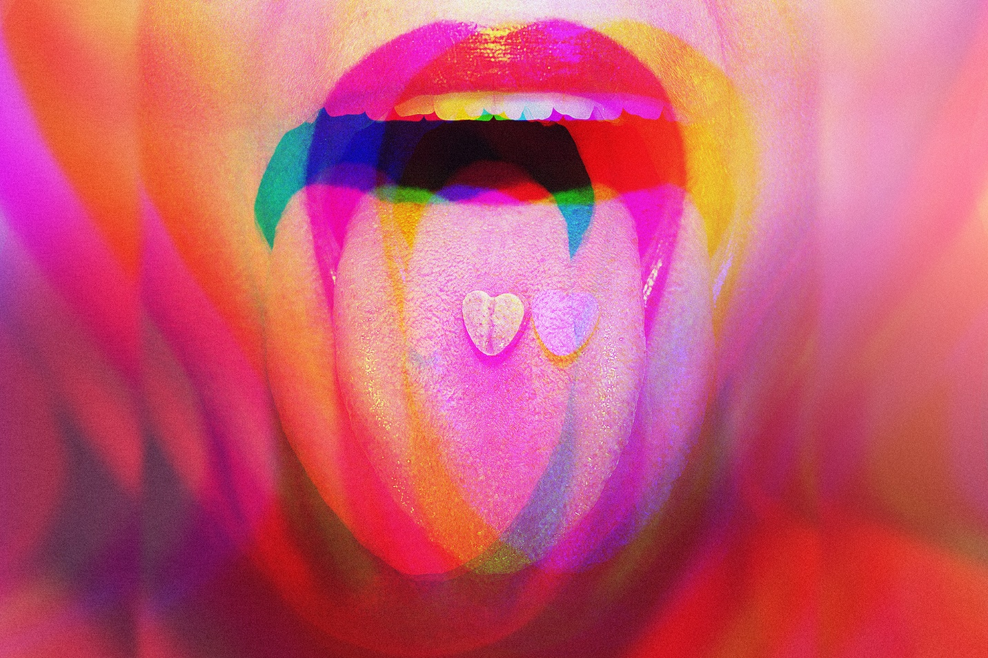
Jun/Getty Images

Haleema Shah joined Today, Explained in 2019. She produces, reports, and guest hosts episodes on the controversies and curiosities of the day.
2024 was supposed to be the year MDMA, better known by its street variations, “ecstasy” or “molly,” shed its reputation as a mere party drug. Advocates touted its potential to treat mental illness, but MDMA research was long stymied by its status as an illicit drug with no medical use.
This year, the FDA reviewed Lykos Therapeutics’s late-stage clinical trials, which paired MDMA with psychotherapy to treat post-traumatic stress disorder. But on Friday, what was expected to be a landmark moment for the use of psychedelics in medicine ended in a rejection from the agency.

Read more about the mystery of psychedelics
- The biggest unknown in psychedelic therapy is not the psychedelics
- Why psychedelics produce some of the most meaningful experiences in people’s lives
- Psychedelics could treat some of the worst chronic pain in the world
Have questions, comments, or ideas? Email me: haleema.shah@voxmedia.com.
It was a far cry from what most observers expected when I began reporting on MDMA-assisted therapy at the beginning of the year. Clinicians and patients were (and remain) overwhelmingly supportive of researching psychedelics for psychiatric use. In the absence of novel treatments for PTSD, MDMA received surprising bipartisan support in Congress and the Department of Veterans Affairs was instructed to prepare a rollout of the treatment.
But even before the FDA’s rejection, its advisers were concerned about research bias, trial misconduct, and data integrity. While the rejection does not fully quash hopes of the drug’s future in medicine, it will delay it. Lykos Therapeutics announced that the FDA requested an additional phase 3 trial to further study safety and efficacy of the treatment, something that the company CEO said would take several years to complete.
The delay is a critical blow to psychedelic advocates who expected that MDMA would finally find therapeutic use after four decades of advocacy. Here’s how they got MDMA this far — and what they’re planning next.

The roots of therapeutic MDMA
When I began reporting on MDMA’s roots in therapy for Vox’s podcast Today, Explained, I visited Shulgin Farm, the Bay Area home of the late chemist Alexander “Sasha” Shulgin, who synthesized the drug in 1976. Though his lab — a converted tool shed — looked more like a Hollywood rendition of a meth lab than the sterile laboratories of my college chemistry class, it was historically significant, because Shulgin is said to have synthesized hundreds of psychoactive substances, some of which he tested on himself, including MDMA.
Shulgin would admit he found MDMA enjoyable, calling it a “low-calorie martini.” But he didn’t set out to design recreational drugs.
“I’m looking for tools that can be used for studying the mind,” and he believed his peers could then use those tools in neuroscience or psychology, he said in a 1996 interview.
His wife, Ann Shulgin, who died in 2022 and is sometimes referred to as “a lay therapist,” was even more ardent about her view of psychedelics as “spiritual tools.” In the early 1980s, she and countercultural psychotherapists believed that MDMA, with its ability to flood people with feelings of love and empathy, could relieve clients of shame and allow them to process trauma or face challenging emotions.
“This chemical has already accomplished enough so that many psychiatrists who have used it, and are using it, have spoken of a possible need to substantially restructure the classical psychotherapeutic 50-minute hour concept,” Ann wrote in a letter to President Ronald Reagan, arguing for the drug’s legal use.
That description bears striking resemblance to what some trial participants say today: An 18-week treatment regimen with MDMA and psychotherapy can relieve PTSD symptoms that years of therapy and SSRI prescriptions couldn’t. But MDMA’s development as a therapeutic drug was hindered by its reputation as a medically useless street drug.

MDMA’s descent deeper into the underground
Despite underground therapists’ belief in MDMA’s therapeutic potential in the early 1980s, the euphoric experiences the drug induced could not be contained for long. MDMA escaped the therapeutic space, was produced in clandestine labs, and found a home in nightclubs as “ecstasy” or “X.”
And it happened during a drug war that already banned psychedelics like LSD. By 1985, MDMA was quickly placed under emergency ban after the DEA said it posed a public health risk.
“There was a lot of lurid press about MDMA,” Paul Daley, a friend of the Shulgins and chief science officer at the Alexander Shulgin Research Institute, told me. “Brain scans were showing ‘Oh, there are holes in people’s brains who are taking MDMA.’ Of course, it’s all hogwash.”
The most damning study of MDMA was in the early aughts, and suggested it caused Parkinson’s-like brain damage, but the study was retracted after a major experimental error was discovered. Evidence, however, supports that MDMA can cause rapid heart rate, cardiovascular events, and bad trips.
As DARE programs and news reports warned of the dangers of ecstasy, a community of evangelists remained committed to bringing MDMA into respectability through medicine.

MDMA’s makeover and foray into medicine
Shortly after MDMA was banned, a friend of the Shulgins by the name of Rick Doblin sprung into action. With the goals of “mass mental health” and “spiritualized humanity,” Doblin founded the Multidisciplinary Association for Psychedelic Studies (MAPS), an organization he still leads, and is regarded as one of the most successful psychedelic advocates.
“To bring psychedelics back from the underground, it was necessary to, first off, have a patient population that the general public is sympathetic with and for which Big Pharma’s drugs are not really working,” Doblin said in a 2021 interview with self-help guru (and former presidential candidate) Marianne Williamson.
The sympathetic population he described are military veterans, who face high rates of PTSD and for whom first-line treatments are decades-old SSRIs that are partially effective.
Doblin’s organization and pharmaceutical spinoff, Lykos Therapeutics, are responsible for the clinical trials that the FDA reviewed this month. But months before the agency announced its decision, the trial design was criticized for not meeting the gold standard of clinical trials, which is to be double-blinded. Participants were usually able to determine whether they received the drug or placebo because of MDMA’s obvious psychedelic effects. Moreover, some who received the drug said they felt pressured to report positive results because their participation was framed as “making history” and “part of a movement” to end psychedelic prohibition.
Friday’s FDA decision is a blow to the decades-long efforts to medicalize MDMA, but psychedelics are now more mainstream than ever — they’re a subject of discussion at the VA, on wellness podcasts, and studied in academic institutions around the world.
And in a statement, Doblin showed no signs of quitting his 40-year odyssey of mainstreaming psychedelics: “Our collective commitment to MDMA-assisted therapy remains unwavering.”

